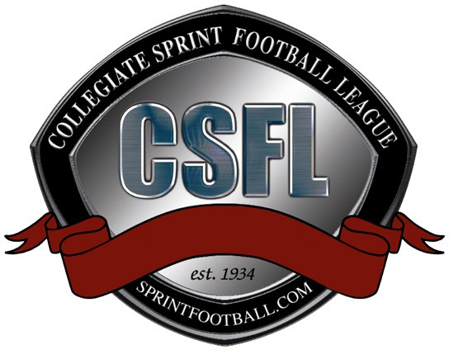

CSFL Virtual Meeting Summary
Thursday, July 16 – 11:00am

Meeting Participants:
Alderson Broaddus: Lee Bradley and Brad Jett
Army West Point: Gene McIntyre and Mark West
Caldwell: Mark Corino, Joe Giacchi, and Jim Kelly
Chestnut Hill: Jesse Balcer and Gio Thomas
Cornell: Terry Cullen and Willie Evans
Mansfield: John Evans and Peggy Carl
Navy: Jason Dewald and Matt Munnelly
Penn: Brad Fadem and Jerry McConnell
Post: AJ McNamara and Adam Schultz
St. Thomas Aquinas: Nicole Ryan, Andrew Tartara, and Matt Barry
CSFL Office: Dan Mara, Doug DeBiase, and Ellen O’Brien

Virtual meeting commenced at: 11:00am

- Welcome/Updates
  - The conference office had new CSFL logo options created for the League to consider. An email will be sent out following the meeting requesting feedback regarding the logos presented.
  - The Football Writers Association of America confirmed that CSFL members are eligible for their Merit and Courage Awards. Individuals for each award are recognized throughout the season. An individual in each category is then honored as the annual award winner and is honored during the Armed Forces Bowl (Merit Award) and Orange Bowl (Courage Award).
  - The Ivy League (Cornell and Penn), CACC (Caldwell, Chestnut Hill, and Post), and PSAC (Mansfield) have announced that no competition will take place during the Fall semester in their respective conferences. The ECC (St. Thomas Aquinas) is likely to make the same announcement tomorrow.

- Fall 2020/Spring 2021 Season Discussion
  - The membership was surveyed regarding playing season structure for the 20-21 year. The majority of schools are in favor of playing a schedule during the Spring 2021 semester. Post may not be competing in sprint football at all during the 20-21 year. Penn and Cornell will need to get approval from their institutions before proceeding with a Spring season. Several schools responded that they will not be able to make overnight trips and have provided mileage guidelines for day trips. Late April is the preferred end time for the regular season. Seven schools will not be able to compete during the Fall semester. One school is undecided but will not likely be able to compete in the Fall. Two schools are able to compete in the Fall.
  - Brad Fadem made a motion to postpone the Fall 2020 Sprint Football Season and to work towards playing the schedule in Spring 2021. The possibility of a Spring season will continue to be evaluated throughout the Fall. Mark Corino seconded. Motion approved: 10-0. The conference office will develop several schedule options that have April 24th as the last date of the regular season. Schools may need to secure neutral fields if overnight travel is an issue. A release regarding the decision to postpone the Fall 2020 season will be drafted today and posted tomorrow.

- Fall 2020 Structure
  - Mark West recommended the Fall semester mirror the usual Spring off-season structure with an expansion in the number of practice opportunities. Mark West made a motion to permit Army and Navy to play two games (home & away) against each other during the Fall semester. Jason Dewald seconded. Motion approved: 10-0. Brad Fadem suggested the games count against their allotment of practice opportunities during the Fall. The games will be considered exhibition contests and will not count towards the regular season standings in the Spring.
  - Schools may have varying resocialization guidelines they must adhere to before conducting team practices in the Fall. The conference office will survey the membership to determine what parameters each institution has in place and develop proposed Fall practice guidelines.
  - Doug will continue to develop marketing and promotional material throughout the Fall semester to highlight sprint football student-athletes.

- Next Meeting: Thursday, July 30th at 11:00am

Virtual meeting adjourned at 11:51am

